LOST
GREYHOUND

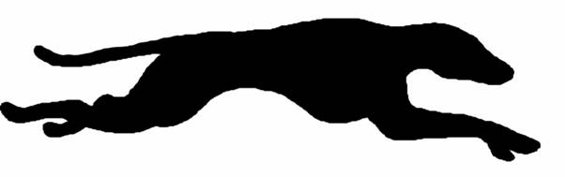

PLEASE DO NOT CHASE, CALL
617-555-1234
OR
617-555-5678

